* 6th Week

HUMAN RESCOURCE MANAGEMENT

<https://www.youtube.com/watch?v=eiLRZfcHovA>

<https://www.youtube.com/watch?v=A2HFusWQIeE&vl=en>

Human resource management (HRM) is the practice of recruiting, hiring, deploying and managing an organization's employees. HRM is often referred to simply as human resources ([HR](https://searchhrsoftware.techtarget.com/definition/human-resources-HR-generalist)). A company or organization's HR department is usually responsible for creating, putting into effect and overseeing policies governing workers and the relationship of the organization with its employees. The term human resources was first used in the early 1900s, and then more widely in the 1960s, to describe the people who work for the organization, in aggregate.

HRM is employee management with an emphasis on those employees as assets of the business. In this context, employees are sometimes referred to as human capital. As with other business assets, the goal is to make effective use of employees, reducing risk and maximizing return on investment ([ROI](https://searchcio.techtarget.com/definition/ROI)).

The modern [HR technology](https://searchhrsoftware.techtarget.com/definition/HR-technology) term human capital management ([HCM](https://searchhrsoftware.techtarget.com/definition/human-capital-management-HCM)) has been used more frequently compared to the term HRM. The term HCM has had widespread adoption by large and midsize companies and other organizations of software to manage many HR functions.

**The importance of human resource management**

The role of HRM practices are to manage the people within a workplace to achieve the organization's mission and reinforce the [culture](https://whatis.techtarget.com/definition/corporate-culture). When done effectively, HR managers can help recruit new professionals who have skills necessary to further the company's goals as well as aid with the training and development of current employees to meet objectives.

A company is only as good as its employees, making HRM a crucial part of maintaining or improving the health of the business. Additionally, HR managers can monitor the state of the job market to help the organization stay competitive. This could include making sure compensation and benefits are fair, events are planned to keep employees from burning out and job roles are adapted based on the market.

**How does HRM work?**

Human resources management works through dedicated HR professionals, who are responsible for the day-to-day execution of HR-related functions. Typically, human resources will comprise an entire department within each organization.

HR departments across different organizations can vary in size, structure and nature of their individual positions. For smaller organizations, it is not uncommon to have a handful of [HR generalists](https://searchhrsoftware.techtarget.com/definition/human-resources-HR-generalist), who each perform a broad array of HR functions. Larger organizations may have [more specialized roles](https://searchhrsoftware.techtarget.com/tip/Nine-different-HR-roles-and-responsibilities-demystified), with individual employees dedicated to functions such as recruiting, immigration and visa handling, talent management, benefits, compensation and more. Though these HR positions are differentiated and specialized, job functions may still overlap with each other.

*Amazon is an example of a large company with multiple types of specialized HR positions. Amazon's career website lists 15 different HR job titles:*

* *HR assistant*
* *HR business partner*
* *HR manager*
* *Recruiter*
* *Recruiting coordinator*
* *Sourcer*
* *Recruiting manager*
* *Immigration specialist*
* *LoA and accommodation specialist*
* *Compensation specialist/manager*
* [*Benefits*](https://searchhrsoftware.techtarget.com/definition/benefits-administration)*specialist/manager*
* [*Talent management*](https://searchhrsoftware.techtarget.com/definition/talent-management-software-TM-software)*specialist/manager*
* *Learning and development specialist/manager*
* *HR technology/process project program manager*
* *HR analytics specialist/manager*

**Objectives of human resource management**

The objectives of HRM can be broken down into four broad categories:

1. **Societal objectives:** Measures put into place that responds to the ethical and social needs or challenges of the company and its employees. This includes legal issues such as equal opportunity and equal pay for equal work.
2. **Organizational objectives:** Actions taken that help to ensure the efficiency of the organization. This includes providing training, hiring the right number of employees for a given task or maintaining high employee retention rates.
3. **Functional objectives:** Guidelines used to keep HR functioning properly within the organization as a whole. This includes making sure that all of HR's resources are being allocated to their full potential.
4. **Personal objectives:** Resources used to support the personal goals of each employee. This includes offering the opportunity for education or career development as well as maintaining employee satisfaction.

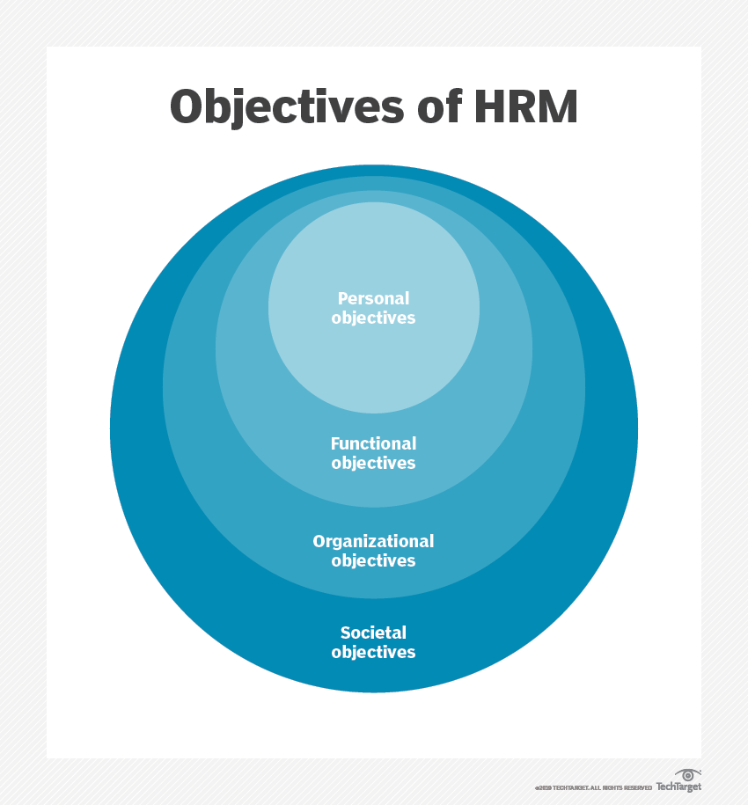

Within the unit of each organization, the objectives of HRM are to:

1. Help the organization achieve its goals by providing and maintaining productive employees.
2. Efficiently make use of the skills and abilities of each employee.
3. Make sure employees have or receive the proper training.
4. [Build and maintain](https://searchhrsoftware.techtarget.com/Guide-to-building-an-effective-employee-experience-strategy) a positive [employee experience](https://searchhrsoftware.techtarget.com/definition/employee-experience) with high satisfaction and quality of life, so that employees can contribute their best efforts to their work.
5. Effectively communicate relevant company policies, procedures, rules and regulations to employees.
6. Maintaining ethical, legal and socially responsible policies and behaviors in the workplace.
7. Effectively manage change to external factors that may affect employees within the organization.

**Skills and responsibilities of an HR manager**

HRM can be broken down into subsections, typically by pre-employment and employment phases, with an HR manager assigned to each. Different areas of HRM oversight can include the following:

* Employee [recruitment](https://searchhrsoftware.techtarget.com/definition/recruitment-management-system), onboarding and retention
* [Talent management](https://searchhrsoftware.techtarget.com/definition/talent-management-software-TM-software) and [workforce management](https://searchhrsoftware.techtarget.com/definition/workforce-management)
* Job role assignment and career development
* [Compensation](https://searchhrsoftware.techtarget.com/definition/compensation-management) and benefits
* Labor law[compliance](https://searchdatamanagement.techtarget.com/definition/compliance)
* Performance management
* Training and development
* [Succession planning](https://searchhrsoftware.techtarget.com/definition/succession-planning)
* [Employee engagement](https://searchhrsoftware.techtarget.com/definition/employee-engagement) and recognition
* Team building

Skills that can add value to HR managers include:

* Employee relations
* Job candidate relations
* Sourcing and recruiting
* Interpersonal conflict management
* New employee [onboarding](https://searchhrsoftware.techtarget.com/definition/employee-onboarding-and-offboarding)
* HR software and information system experience
* Performance management
* Customer service
* Project management

**HRM software**

Almost all areas of HRM [have sophisticated software](https://searchhrsoftware.techtarget.com/feature/Determining-requirements-for-buying-human-resource-management-software) that automates varying degrees of many HR processes, along with other added features such as analytics. For example, job candidate recruiting has seen enormous growth in the number of software platforms and systems that help both employers and job seekers to electronically match organizations and candidates with each other and then help manage the interviewing, hiring and employment processes.

While some HRM software systems started out on premises, nearly every area of HR tech, especially HCM systems, is moving to cloud-based software as a service (SaaS) platforms.

**HRM career opportunities and requirements**

When looking to start a career in human resource management, a bachelor's degree is typically required. Some colleges offer specific human resource management degrees, which can be one path into an entry-level HR position. Another way to land a job in HR is to complete an undergraduate course of study in a related field, such as business administration. Furthermore, several years of experience in operations-heavy roles may prove valuable when making a career transition into HR positions. For those lacking a relevant undergraduate degree or translatable work experience, there are also HR-specific master's degree programs to help build the necessary knowledge, skill sets and qualifications.

**Modern HRM history**

The birth of modern human resource management can be traced back to the 18th century. The British Industrial Revolution, giving rise to many large factories, created an unprecedented spike in worker demand.

With many of these laborers putting in long hours (often clocking in around 16-hour workdays), it became increasingly apparent that the happiness of workers had a strong positive correlation with productivity. Seeking to maximize return on investments, worker satisfaction programs started to be introduced. Furthermore, factory labor conditions brought worker safety and rights to the forefront of legal attention.

Early HR departments within organizations in the 20th century were often known as personnel management departments. The personnel management departments dealt with legal [compliance](https://searchdatamanagement.techtarget.com/definition/compliance) and employee-related issues, and also implemented worker satisfaction and safety programs within the workplace. Following WWII in the United States, personnel management departments looked to the Army's training programs and started to make employee training a point of emphasis.

HR departments started to assume the name of "human resources" in the 1970s. The primary factor that differentiates HR from personnel management is the technological enablement of better communications and access to individual employee information.

**HRM trends**

Job opportunities for careers in human resource management remain strong. The Wall Street Journal, in an analysis of data released by the [Bureau of Labor Statistics](https://whatis.techtarget.com/definition/United-States-Department-of-Labor) (BLS), ranked the "HR manager" job title as the 35th (out of 800) most promising prospect, based on median salaries in 2018 and projected job openings in 2028.

Generally speaking, human resources as a field is on the upswing. Companies are increasingly recognizing the strategic difference a good HR department can make and are investing in them accordingly. As a result, HR jobs are growing in demand. There is expected to be a 7% growth in HR manager job titles alone within the United States from 2018 to 2028. Furthermore, salary prospects remain strong, with the median HR manager salary currently sitting at around $113,000. For HR specialist positions, median salaries sit at around $60,000.

*“Continuous innovations in technology will fundamentally change the way HR work is accomplished”* [[4](https://www.intechopen.com/chapters/62362#B4)]. Information systems have a deep effect on HRM. It transformed human resources processes and practices mainly in terms of how organizations collect, store, use, and disseminate information.

In fact, the principal goals of HR in organizations are to attract, select, motivate, and retain talented employees in their roles, and “*technology has transformed the way HR processes are currently managed, essentially how organizations collect, store, use, and disseminate information about their HR”*